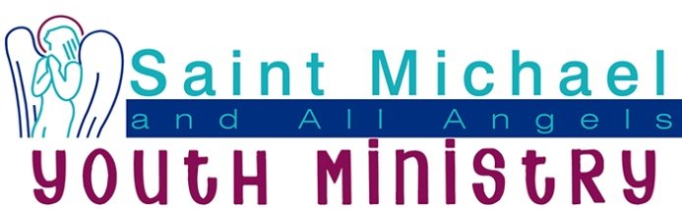
Mission Statement: Saint Michael and All Angels’ Youth Ministry engages, nurtures, and inspires our youth community to become confident disciples of Jesus Christ.

Benchmarks/Goals for Your Ministry

2019 Three-Year Revolving Goals
- Thirty percent of confirmands per grade (7th-12th) participated monthly in at least one youth program activity beyond Sunday worship (such as EYC, small groups, Sunday School, Bible Study, etc.)
- 2017 Benchmark: Ten percent of confirmands from 2015-2016 participated monthly in at least one youth program activity. (65 confirmands 2015-2016)

- Adult volunteer to student ratio per function improved to 1:5, drawing from all parish ministry groups.
- 2017 Benchmark: Our adult volunteer to student ratio per function improved to 1:8 drawing from all parish ministry groups.

- More than 75 individual youth per month assisted in worship, serving as acolytes, A/V support, choir, readers, greeters, etc.
- 2017 Benchmark: 65 individual youth per month assisted in worship, serving as acolytes, A/V support, choir members, readers, greeters, etc. (number unknown at this time)

- A pilgrimage for high school youth has been offered every other year.
- 2017 Benchmark: One pilgrimage for high school youth.

- Annual mission trips for both middle school and high school youth have been offered.
- 2017 Benchmark: One pilgrimage for each age group.

- Four small-group Bible studies, breakfast or dinner groups have met at least twice a month and completed one service project annually.
- 2017 Benchmark: Two small group Bible studies have met at least twice a month. (Friday HPHS, Sunday study hall, Bible study and dinner Sunday evenings at SMAA)

- Six first-time visitors per each of the seven grade levels (42 youth) have attended a youth ministry program at least once annually and SMAA has followed up to maintain relationship with intent of welcoming host, growing youth participation versus conversion or “hard evangelism.”
- 2017 Benchmark: Three first-time visitors per grade level (21 youth) have attended a youth ministry program at least once annually. Youth visitor communication piece/brochure in print and digital format with contact info to be created and shared.

- Youth have actively collaborated with children and family ministries in at least four intergenerational events per year.
- 2017 Benchmark: Youth have actively collaborated with children and family ministries in at least two intergenerational events per year.

- Ministers maintain a “Relationship Building Calendar” whereby they are out in the community meeting with parishioner adults and youth, attending youth sport or creative events and being available for events, coffee, meals, etc. to show support to church community and get to know parishioners. Minimum of 2 parishioner relationship touchpoints per week totaling approximately 100 parishioners/family units per Youth Minister per year.

- Youth have actively engaged in community service projects throughout the year. Participation is required to attend all mission trips and pilgrimages.

